Shenzhen Seetong Technology Co., Ltd

NVR-6036A smart AI specification
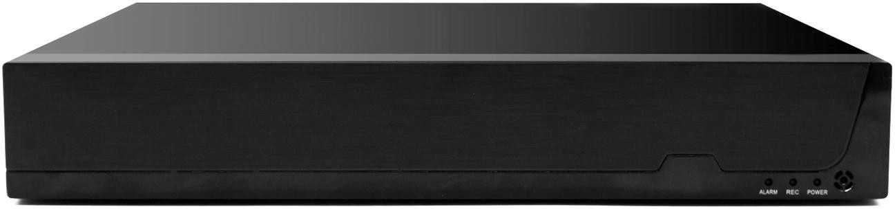

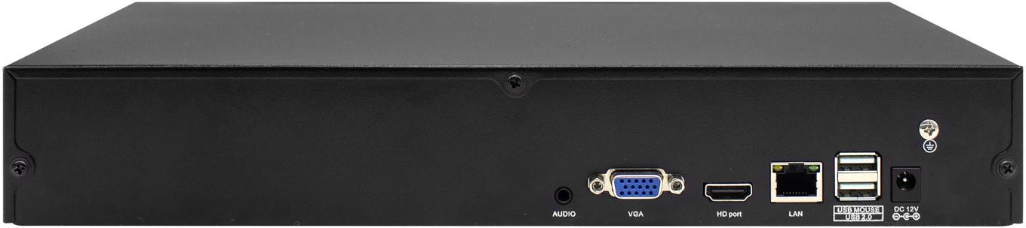

Product technical features
Support 36Ch 4K input

Support face capture and comparison function and license plate capture function;
Maximum support for accessing 25 channels of camera capture and comparion

Support max. 1ch NVR do face capture and comparision, NVR can connect max.
16 Channel camera.
Built-in face database, which can save up to 1000 faces;
Support AI functions such as human figure detection, face capture, and face comparison, global license plate capture( output contents include license plate color, license plate number, support OSD overlay license plate number and color to video part ).
Support 4K video output, HDMI supports synchronous output audio;
Support 2 hard disk access, each support maximum 16TB HDD ;
Support to search video by name, search video by picture; video query is faster
Support a variety of comparison rules, and can set different linkage functions;
Support 3.5mm audio interface, expandable input and output;

Shenzhen Seetong Technology Co., Ltd
36-channel mode: playback 4-channel 5MP/25-channel mode: 4-channel 4K;
The video playback is displayed on the time bar , and the video type is indicated by color, so it is convenient and quick to retrieve the video data;
Support video backup function , the backup can be accurate to 1 second;
Support batch modification of camera IP addresses , plug and play, and cross-network segment image output functions ;
Support ONVIF protocol;
Support the function of controlling the image parameters of the camera ;
Multiple playback modes, fast forward, fast rewind and other functions ;
Support monitor and playback video remotely with EasyVMS software ;
Support remotely monitor and playback video with HiEasy APP;

Product parameters

system
model | NVR-6036A
main chip | A1X
operating system | Embedded Linux operating system
interface
Operation  interface | Graphical operation interface, support mouse/ keyboard operation
screen display | 1/4/6/9/16 /25/36 screen
video
video access | 36ch mode: 36 ch 5MP/25ch mode: 25ch 4K
video frame rate | NTSC@30 fps, PAL@25fps
video output | VGA*1, HDMI*1
image decoding | H.264/H.265
area occlusion | Support ( requires camera support)
Motion Detection | Support ( requires camera support)
Smart function
electric fence | Support, alarm functions such as linkage push, full screen display when trigger  alarm , video recorder voice broadcast ( requires camera supporting)
Out of bounds  detection | Support, alarm functions such as linkage push, full screen display when trigger  alarm , video recorder voice broadcast ( requires camera supporting)
Off- duty  detection | Support, alarm functions such as linkage push, full screen display when trigger  alarm , video recorder voice broadcast ( requires camera supporting)
Passenger Statistics | Support query passenger flow data ( requires camera supporting)
Face database | 1000
AI Channel | 36Ch format: 4ch face comparision (4ch camera do face capture and comparision) 32ch format: 8ch face comparision (8ch camera do face capture and comparision) 25ch format: 25ch face comparision (8ch camera do face capture and comparision)  16ch format: 16ch face comparision (16ch camera do face capture and comparision) or  1ch face capture and comparision by NVR.
Face capture | Support face capture, camera must be with face capture function
Face comparision | Support face comparision function, camera must be with face capture function. Support black/white list face comparision, support multi-rule setting.
License Plate Capture | Support Global License Plate Capture. Max support 5000 license plate photos.
play back | Support AI human shape , car shape playback function, more accurate playback.
audio
voice alarm | The voice alarm prompt can be set ( the camera needs to support the voice alarm  prompt)

audio format | G.711U ,G.711A, G.726
audio intercom | Support, need to connect audio extension
audio input | 1:1 network audio input according to the number of channels
Audio output | Support HDMI output audio, 1.25 socket connected speaker sound output,  supports 3.5 mm audio output
video playback
Video mode | Timing recording, motion detection recording, manual recording , intelligent
 | recording
Number of playback  channels | 3 6 -channel mode: 4- channel 5MP playback / 25-channel mode: 4-channel 4K  playback
Video query | Time bar playback, browse playback , smart event playback
storage backup
video storage | local hard drive, network
backup method | USB mobile hard disk, U disk
Remote monitoring
Phone  monitoring | P6SLite
computer  monitoring | VMS client remote monitoring
external interface
video output | 1 VGA, 1 HDMI interface
Network Interface | 1 RJ45 100/1000MB adaptive Ethernet interface
Alarm interface | none
485 interface | none
USB interface | 2 USB 2.0 interfaces
Hard disk interface | 2 SATA 2.0 interfaces; each SATA interface supports a maximum capacity of 8TB
other
PTZ control | Control the camera with PTZ device through the network
ONVIF | support
power supply | DC 12V 5A
power consumption | ≤ 15W (without HDD)
working  environment | - 10 C~ + 50 C 10 % ~ 95 % RH
size | 326mm*242mm*52mm（L*W*H）

Shenzhen Seetong Technology Co., Ltd

Product parameters Interface definition

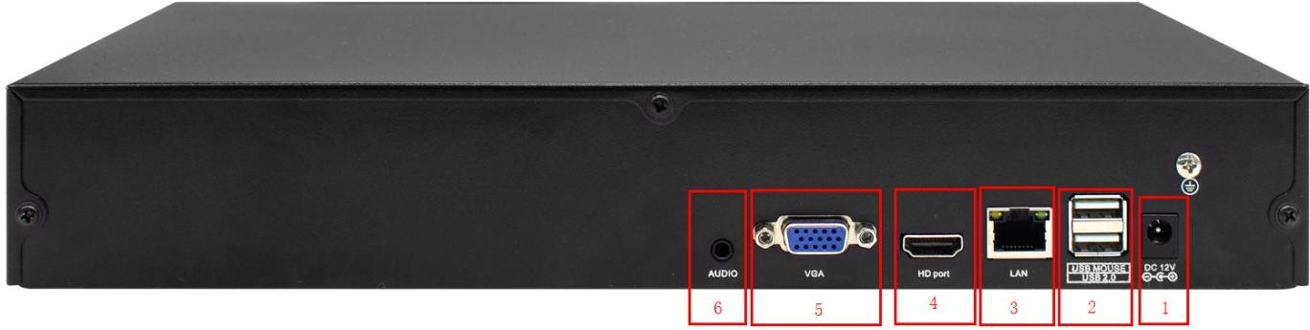

1 | 12V input | 2 | USB interface | 3 | RJ45 network gigabit  ( standard configuration)
4 | HDMI output | 5 | VGA output | 6 | 3.5 mm audio  output/input

The content in this specification is only to provide guidance for users. Our company will update the content of this specification according to the enhancement or change of product functions, and will regularly improve and update the software functions described in this specification. The updated content will be reflected in new editions of the specification without notice.

